


FOUNDATION Apprenticeship –

H3BB 04 Data Modelling

WorkBOOK – ICT Software Work Placement

Student Name: Allannah Stewart

Contact details:

Contents
Introduction 4
Describing data 4
Organising data 4
Entity Relationship Diagrams 5
Entity relationships - cardinality 6
Exercise 7
Conclusion 7
Conclusion 7
Unique Identifiers 8
Foreign Keys 9
Surrogate key 10
Entity Integrity 10

Learning OUtcome 1
Understanding the concepts of logical data modelling
This section will be assessed in a closed-book assessment (with no access to reference materials) consisting of multiple choice questions.

Introduction
This section introduces the techniques of data modelling which allow you to take actual data and analyse it to produce a model that will help you create a relational database. It introduces data analysis terms and relational database terms, along with Entity Relationship Diagrams and Data Dictionaries which are key aids in database design.

Describing data
Any real world phenomenon about which we want to record data can be described as an entity.
**QUESTION:
IN SIMPLE TERMS WHAT IS AN ENTITY?
__A thing that we want to record data about_________________
For each entity, we need to establish what data items or attributes we need to record. This will depend on the type of processing we need to perform.
For example, in a business which sells products online, there is a need for a sales order database. For each customer the database needs to store details of how to contact them and where to deliver to them. These are the attributes relevant to our scenario. It does not need to store how many siblings they have or how tall they are.
In this scenario the entity is the customer, and some of the attributes we might need are a contact telephone number, email address, and a delivery address in all its component parts.
**QUESTION:
GIVE ANOTHER EXAMPLE OF AN ENTITY AND ATTRIBUTES:
A class the attributes would be age, grade, name and house

Organising data
Once we understand what entities we need to record and what attributes we need for each one, we could just make a list and store each sales order in a spreadsheet.
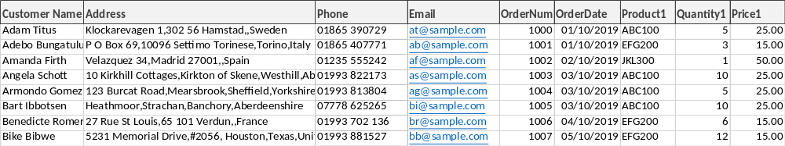
However, this would mean that when the customer came back to us to make another purchase, we would effectively start from scratch and record their details again. This becomes a problem when the customer contacts us to discuss their order, and we find multiple occurrences of their name, some of which may represent this person, and some may be others with the same name.
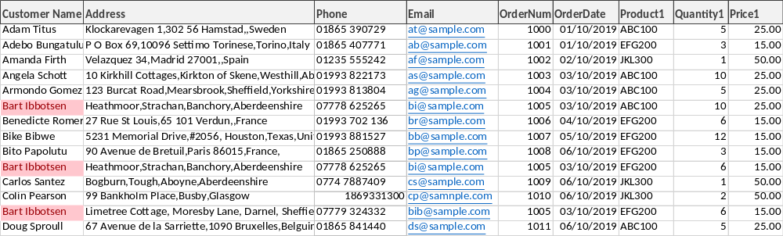
The other problem with a flat list like a spreadsheet is that we have to record the same data each time the customer purchases from us, for example the customer’s contact details. This is effectively redundant data, which would be easier to manage if it was stored in one authoritative place for that customer.
Relational databases are designed to overcome these weaknesses

Entity Relationship Diagrams
To move from a flat list to a relational structure with no data redundancy, we need to consider relationships, and this is done using an Entity Relationship Diagram.
To create a diagram that describes our sales order scenario, we need to consider each entity, and what attributes we need for our purposes. So far, we have identified that we have Customers, who place Orders, and each order is for some of our Products.
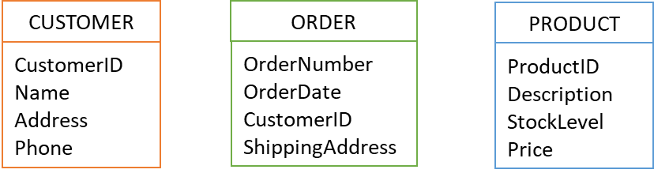
Here are our Entities described with their attributes.
Our current entities do not show how a customer can order multiple products on the same order. To do this we need an entity that links or bridges between the Order entity and the Product entity. This would be the Order Items. We can create a link entity that consists of the OrderNumber, and one of the Products from the order, with the Quantity required. Each Product in this order becomes a separate entity.
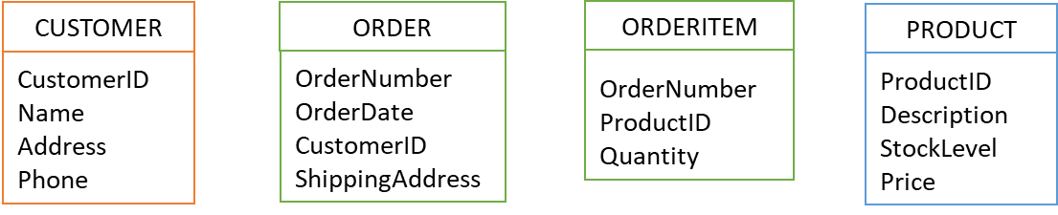

Entity relationships - cardinality
The next step is to describe the connections or relationships between the entities.
We can draw a line to link the Customer to the Order and the Order to its Items, and the Items to the Product, but to tell the whole story we need to consider the Cardinality.
The Cardinality describes the relationship as
one to one

one to many

many to many

We can see that a customer might have one order, or over time they might have many orders.

To establish the Cardinality of the relationship between the two entities you should ask the same question from each side, for example:
What is the minimum number of Orders a Customer might have? | 1
What is the maximum number of Orders a Customer might have? | Many
What is the minimum number of Customers an Order might have? | 1
What is the maximum number of Customers an Order might have? | 1

Conclusion: | there is a one-to-many relationship between Customers and Orders.

**Exercise
- Follow the example above and complete the table below with the questions which will help you establish the relationship between Orders and Order Items, then fill in the answers.
What is the minimum number of Items an Order might have? | 1
What is the maximum number of items an Order might have | many
What is the minimum number of orders an item might have | 1
What is the maximum number of orders an item might have | 1

Conclusion
The type of relationship between Orders and Order Items is: ____one to many

- Now consider the relationship between Products and Order Items, and fill in the answers.
What is the minimum number of Products an Order Item might have? | 1
What is the maximum number of products an order item might have | 1
What is the minimum number of orders a product might have | many
What is the maximum number of orders a product might have | many

Conclusion
The type of relationship between Products and Order Items is: one to many_

**Exercise
Now let’s update the Entity Relationship Diagram for our sales order scenario. You can add the lines to show the cardinality you worked out for each relationship. Draw the lines between the entities to show the ER. 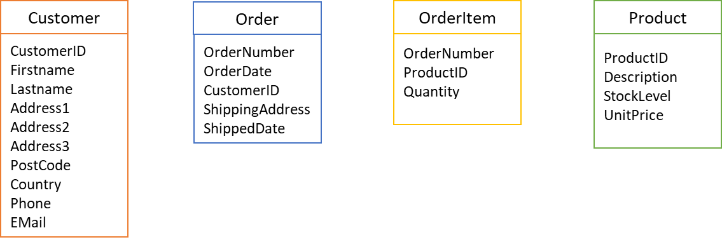

Unique Identifiers
Why do we have a CustomerID when we know our customer’s name? It doesn’t seem very friendly to call them by a number!
The customer’s name may not be unique, so we need to be able to distinguish between, for example, 2 customers called Alan Stevens. We could use a combination of the Name and the Address to identify them, but when our first Alan Stevens moves house, we will have a total of 3 combinations of Alan Stevens and an address. It would then be impossible to identify all the orders relating to either of these customers.
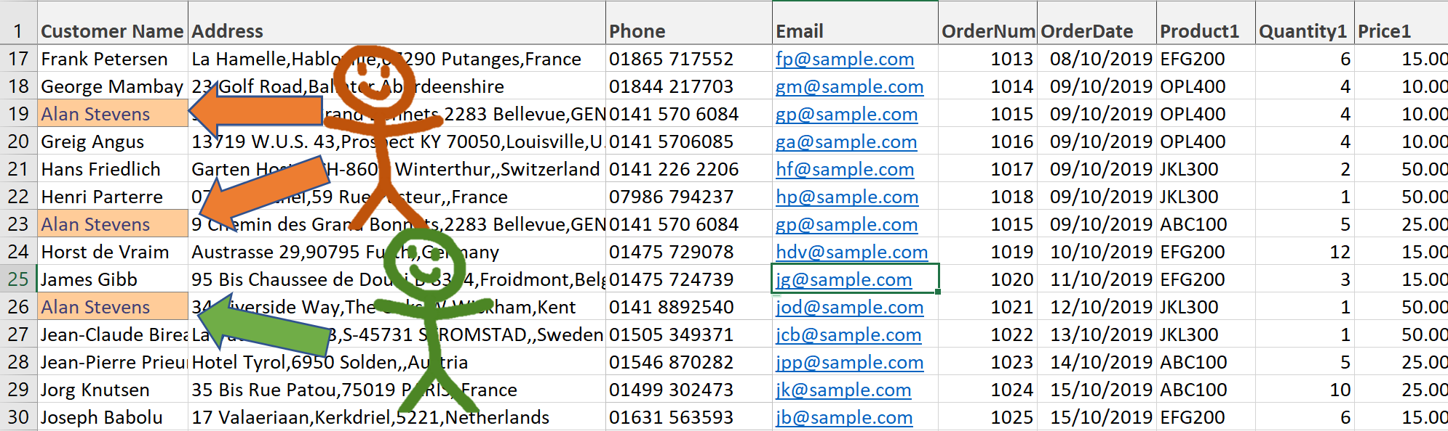
If we add a unique identifier like a Customer Number we can allocate an identifier to each new customer which will stay with them throughout changes to address, phone number and even name, and will allow us to keep track of all their orders. This field will be the Primary Key of the Customer table.
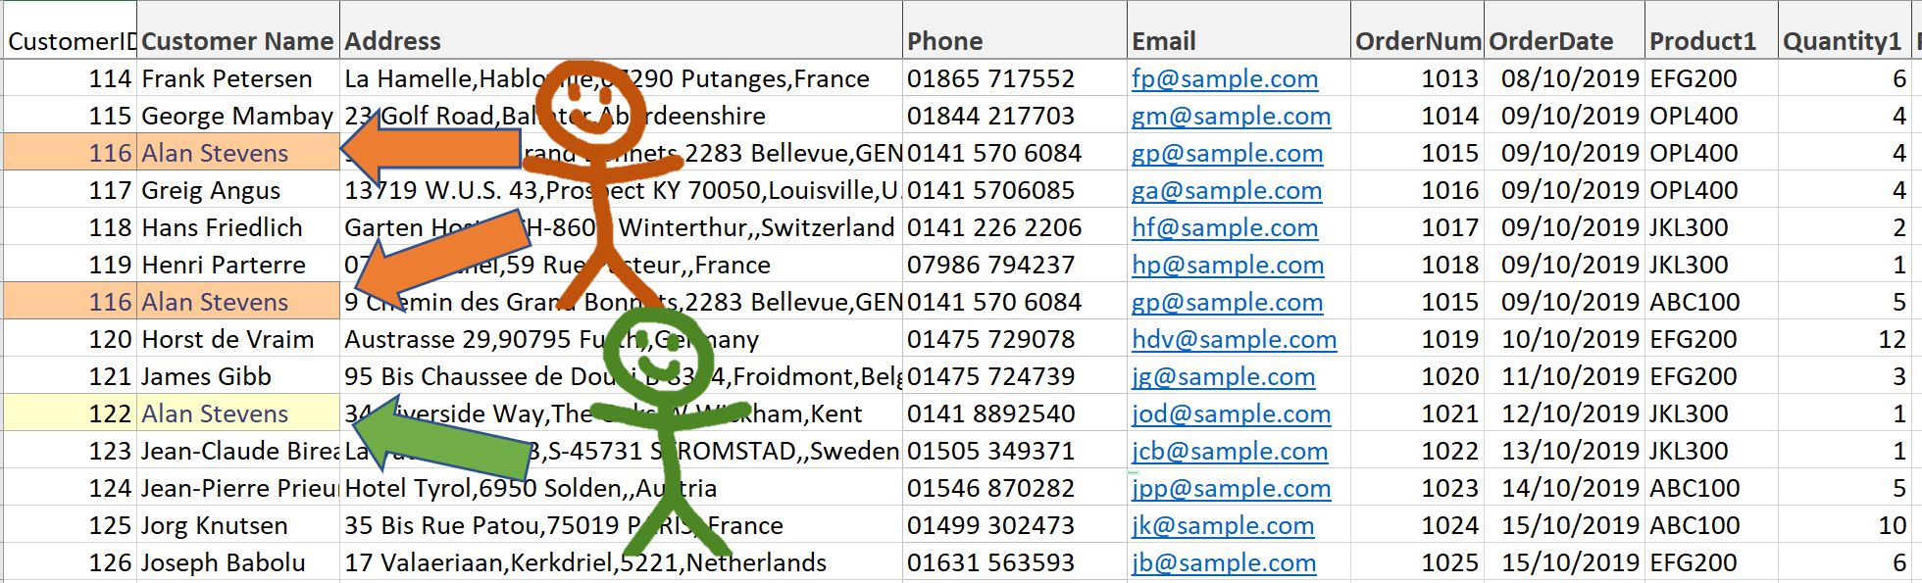
The field or combination of fields which uniquely identifies a record in a table is known as the Primary Key. The field or combination of fields you select for the primary key must meet these 3 rules:
- It must be unique
- It must never change
- It can never be null (left blank)
When we create a table relating to our entities, the Entities become the rows and the Attributes become the columns.
It is an important first step in creating tables from our Entity Relationship Diagram, that we can uniquely identify each entity or record. In the case of our Order Items we will use both the Order Number and the Product Id together. This is called a compound key.
Note : you will also hear the term composite key used for a unique identifier that consists of multiple attributes. In a compound key, the constituent parts are all foreign keys, i.e. primary keys in other tables (see below). In a composite key the parts are not all key fields. The terms are often used interchangeably.
Here are some useful terms we will need in working with databases:
Database | An organised collection of related information
Database Management System | Software which allows related information to be gathered electronically, and searched, sorted and updated.
Field | A storage area for one specific data item or attribute, e.g. Surname
Record | The storage of a logical grouping of fields, e.g. name and address details, which describe an entity
Table | A collection of records containing the same fields.
Primary Key | A field or combination of fields which uniquely identifies a record
Foreign Key | When a field in a table is also a primary key in another table, it is called a foreign key, e.g. CustomerID in the Order table.
Compound key | A key consisting of multiple attributes which are foreign keys
Surrogate key | A field which is created solely as a unique identifier in a table

Foreign Keys
In the situation where you can see that a one-to-many relationship should exist between tables, for example, between Customers and Orders, you need to provide an attribute or field which will link these two tables. The answer is to take the Primary Key of the Customer table, the CustomerID field, and include it in the Order table. When the primary key of one table appears as an attribute of another table it is known as a foreign key.
When we draw the relationship between these tables in the Entity Relationship Diagram, it should specifically link these 2 fields.

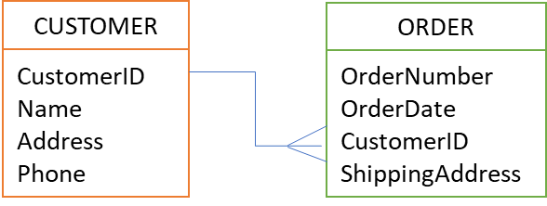

Surrogate key
When you study a table to see what attributes will uniquely identify each record, you may find that it needs a compound key which is a bit cumbersome to work with. In this case you might decide to add a unique number field, which has no purpose other than to be the unique identifier of each entry. This is known as a surrogate key, and can simplify the use of the table in database operations.

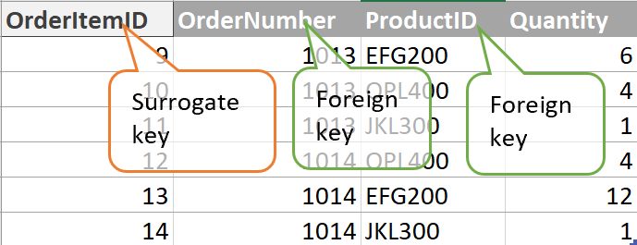

Entity Integrity
Entity Integrity specifies that the Primary Keys on every instance of an entity (every record in a table) must be unique and must have values other than NULL.
The existence of a Primary Key ensures entity integrity. If you define a primary key for each entity, they follow the entity integrity rule:
The primary key for a row is unique; it does not match the primary key of any other row in the table.
The primary key is not null, no component of the primary key may be set to null.
Entity Integrity is enforced by a Relational Database Management System, by not allowing insert and update operations to produce an invalid primary key. An attempt to create a duplicate primary key or a null primary key will be blocked.

