LEARNING OUTCOME 2 - CONTRIBUTE TO THE INVESTIGATION AND DEFINITION OF SYSTEM REQUIREMENTS.
LOGBOOK
Apprentice Name: | Amelie Bonner | Date | 16/05/25
Name of person requesting work | Fiona Young | Job Title
Apprentice or Manager should complete sections 1-5. Person requesting the work should complete section 6.

Describe the project including project objectives
I have been asked to build a website for Tillydrone Community Flat. The website needs to have at least 6 pages including a home page, an about us page, a page for blog posts, a page for activities, a get involved page, and a contact page. The website should be responsive and work on all modern browsers. It should look engaging and inform users about the important work that the community flat does. It should clearly show where it is, how they can get in contact, and when they can go for activities. I will design the website and build it using WordPress. I will communicate with the client and make changes to the website based on the client’s feedback. I will test the website, and I will launch the working website.
2.Describe the process required to achieve a successful result?
- Research websites of similar charities and community centres
- Ask the client about what she wants the website to look like and the content that she wants
- Design wireframes and sitemaps and send them to the client
- Make changes to the layout based on the client’s feedback
- Use WordPress to create the website
- Communicate with the client and make changes
- Test the website
- Put the website online
3.Describe the methodology you will use to achieve a successful conclusion? – This log book/project documents should be used to record the steps.

I researched websites and got information from my client about how she wanted the website to look and what pages she wanted. I then designed a wireframe and a sitemap and sent them to her. My client wanted an about us page that explains what the community flat does and references their partners, a news/blog page with recent stories about the flat, an activities page which lists all of the activities that they provide, a get involved page that allows users to get in touch with the flat, and a contact page with their phone number, email address, and social media. I used my creativity skills to design the layout and I communicated with the client to get feedback.
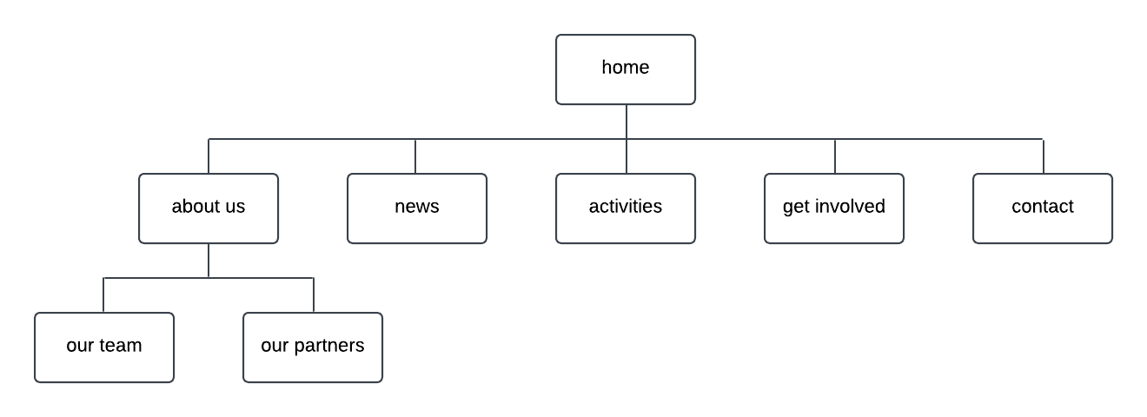

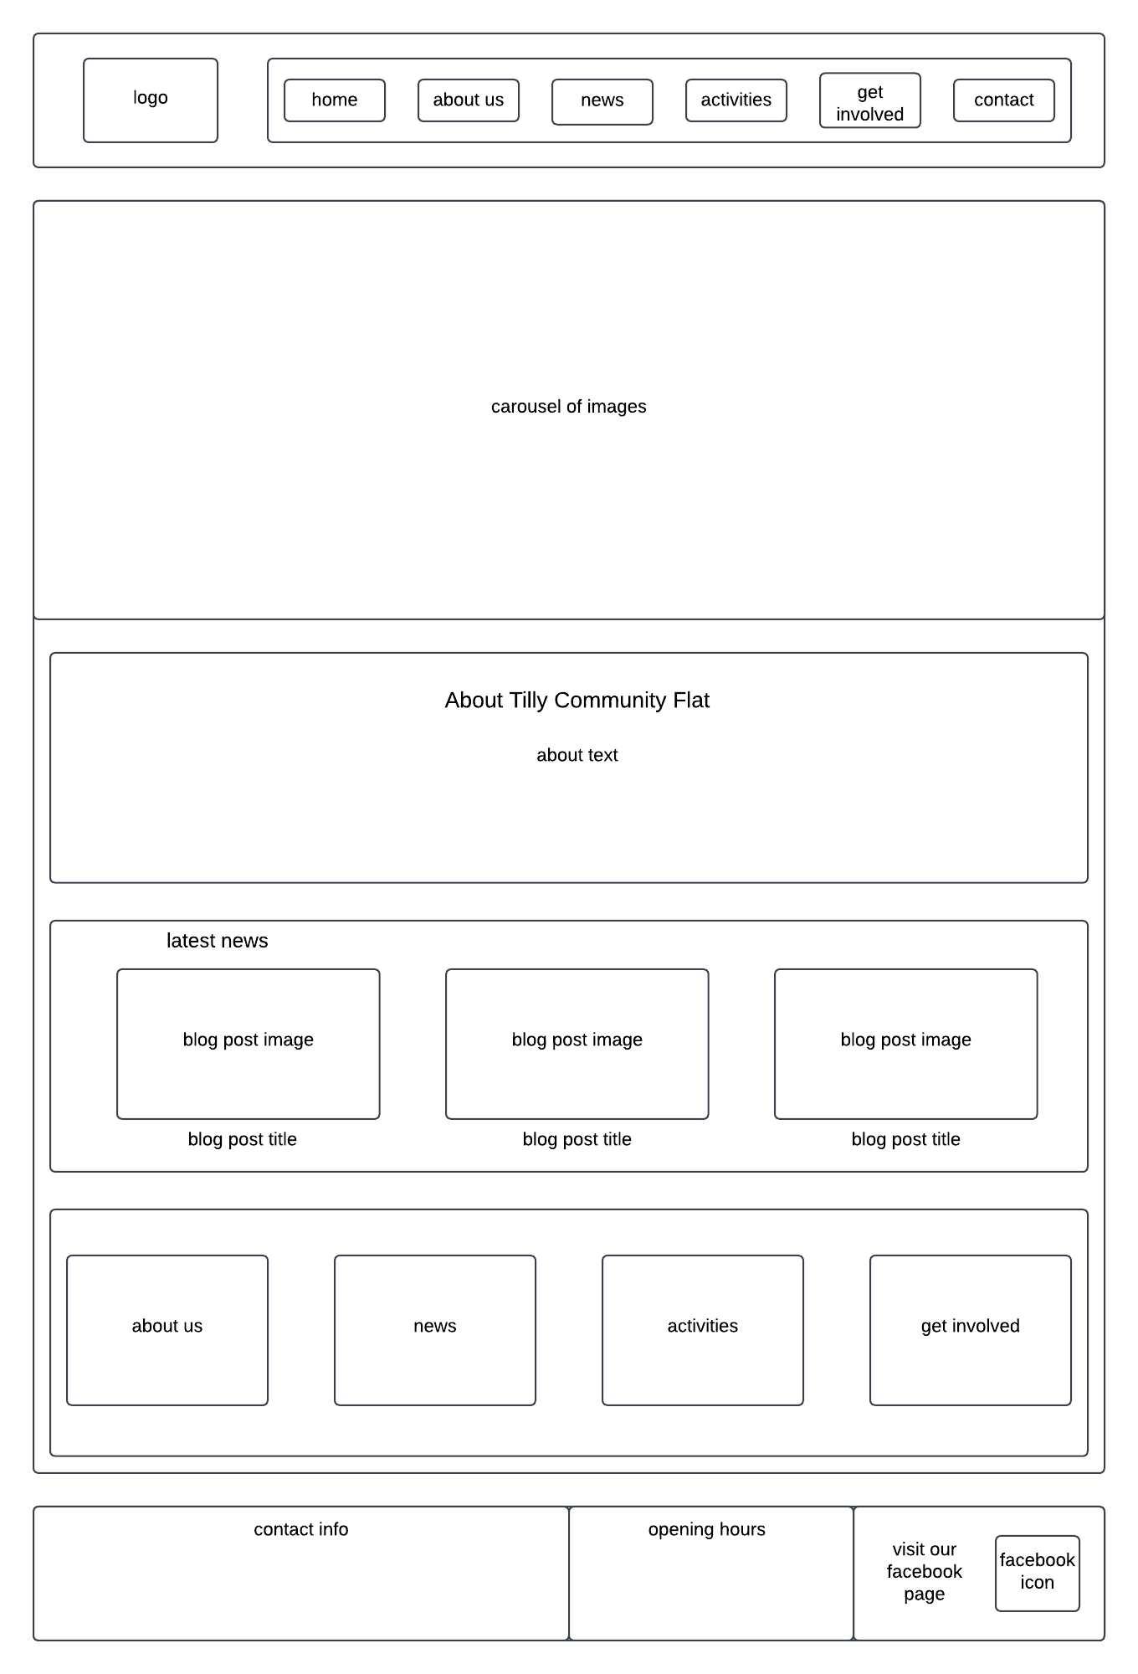

I used WordPress to create the homepage. I looked at the Facebook page for Tilly Community Flat to find images for the website. I also found the text for the about us section when researching the community flat. I added a latest news section to the homepage and buttons from the about us and the news section to the pages where users can find out more. I also added images with buttons at the bottom of the page that link to other pages. The footer includes contact information and the opening hours which I found on the Facebook page. I also included a link to the Facebook page since that was their main form of communication and their only social media. I went with blue as a colour scheme because my client said that the logo was blue and some of the websites that she liked used blue as the main colour.
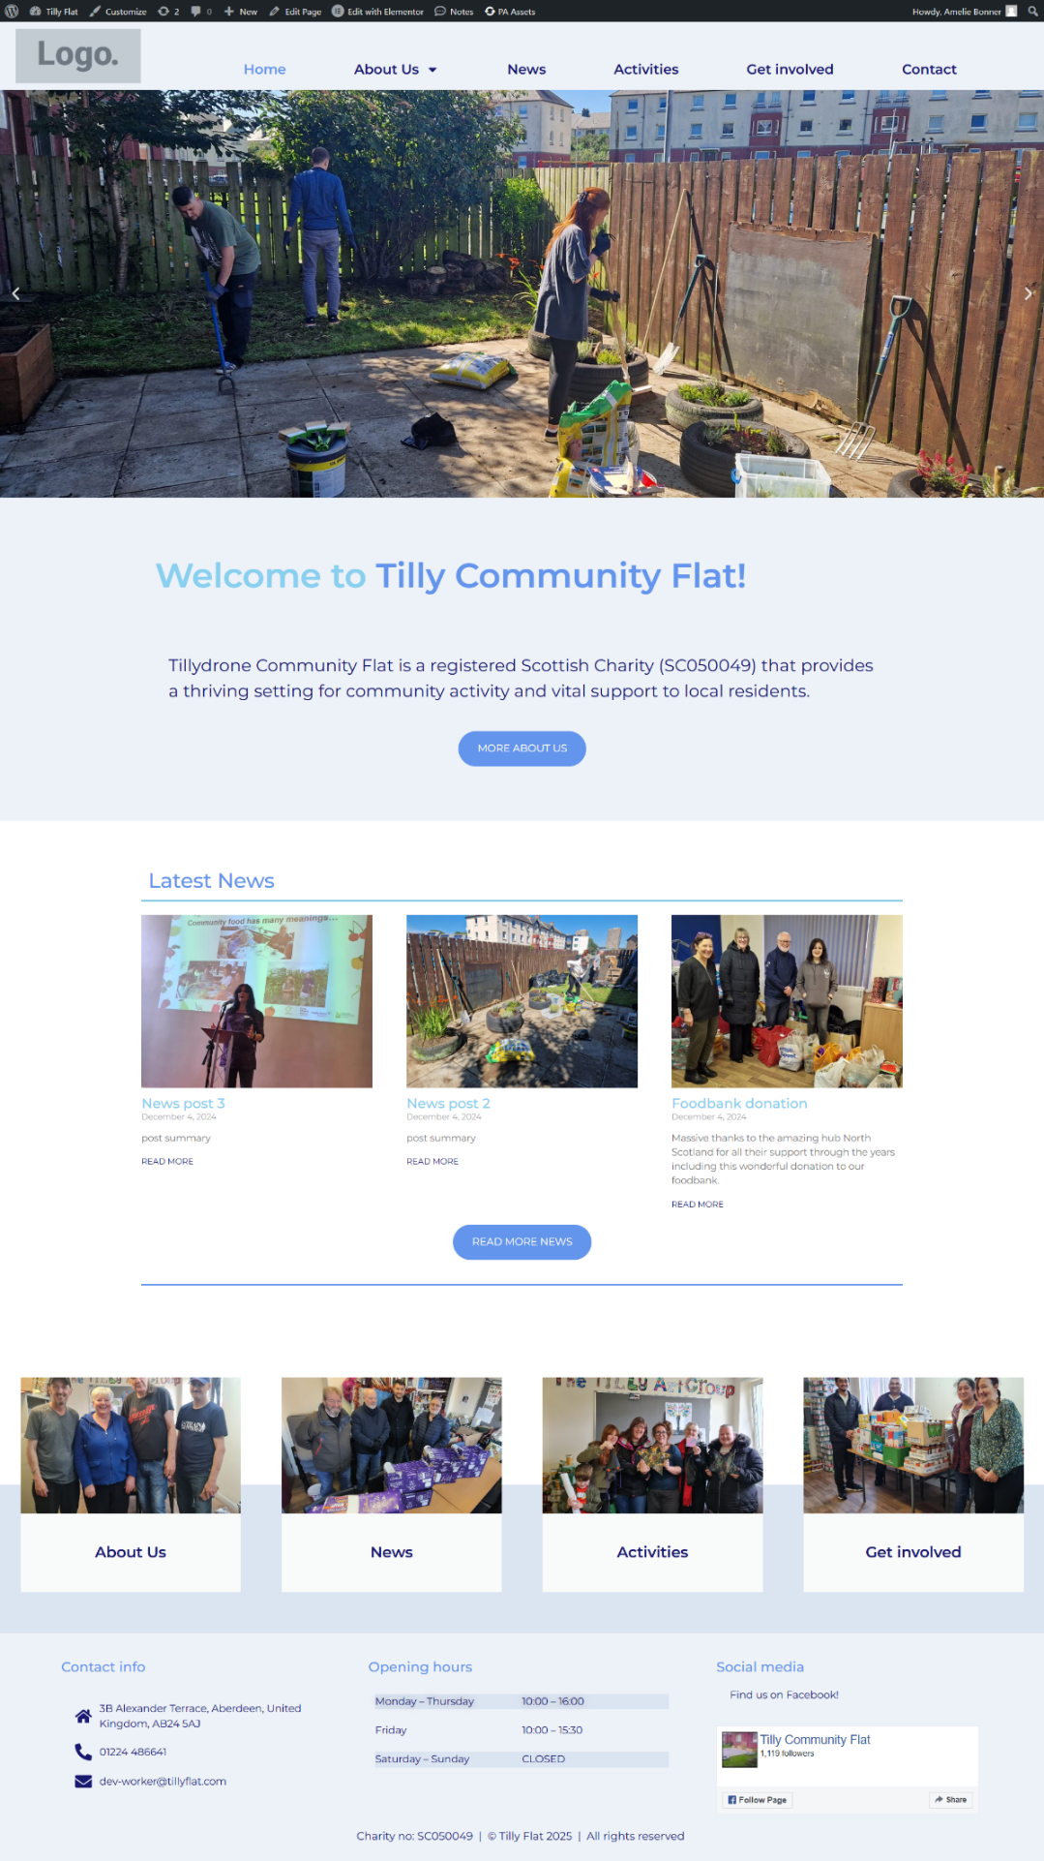

I researched online and took information from different websites for the text for the about us page. I used the image from their profile picture on Facebook for the main image on the page. I used blog posts for the news page. I added a map to the contact page with the address of the flat, phone number, and email address.
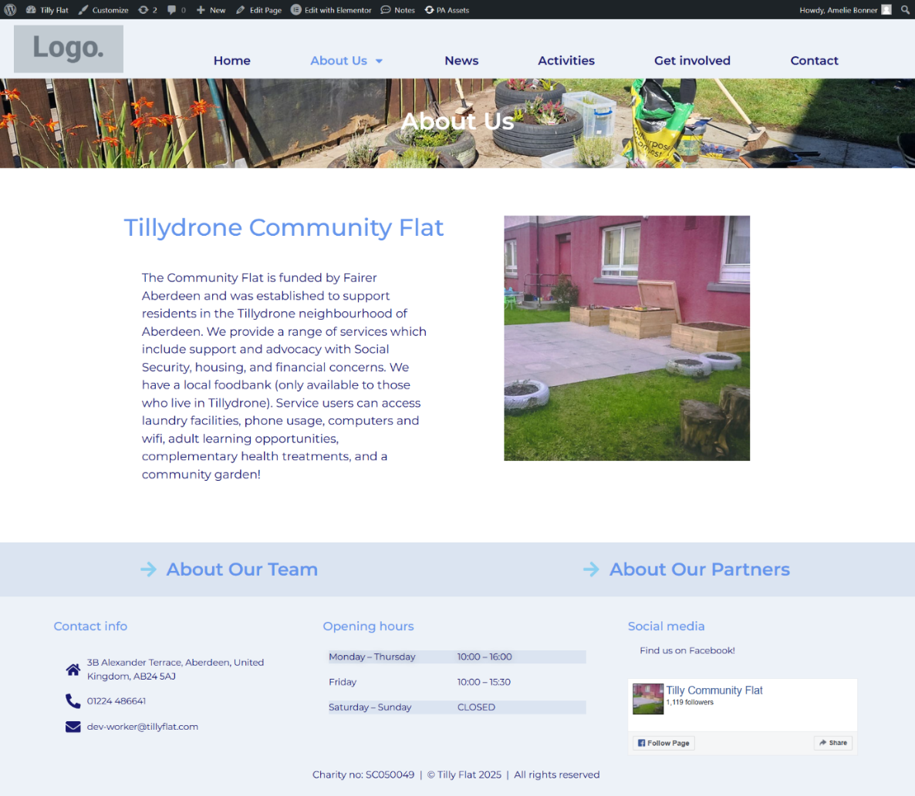

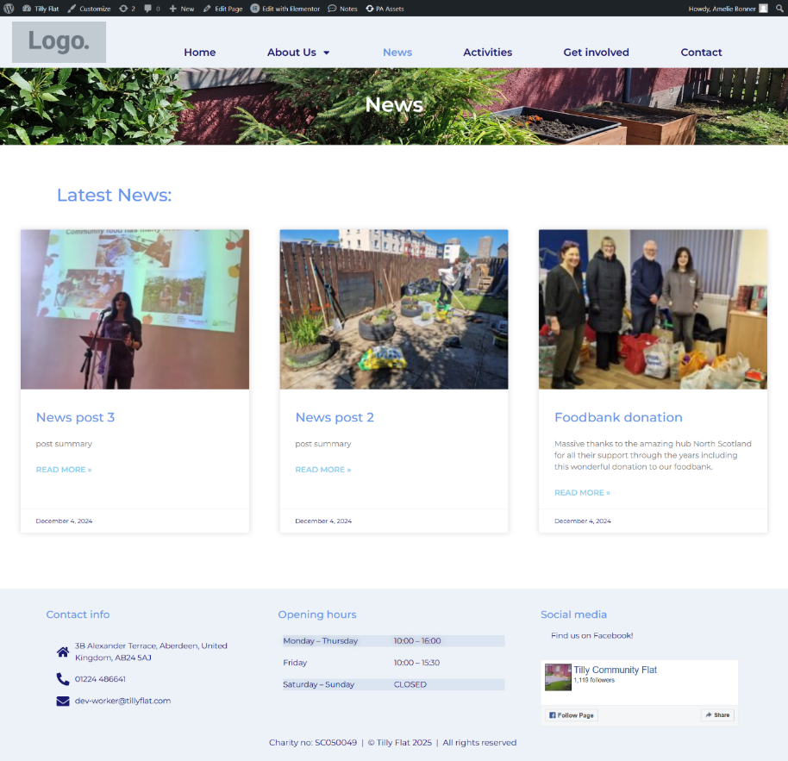

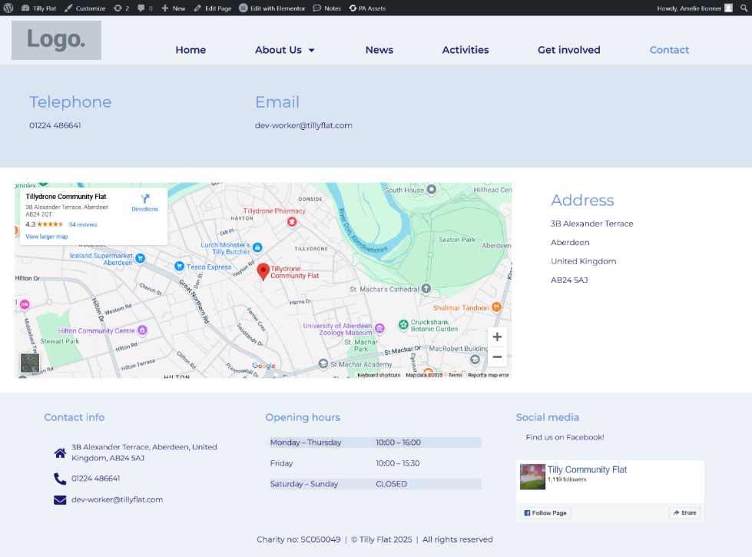

I received the logo from my client and added it to the pages. I decided to add another colour to the website to make it more colourful so I chose a similar colour to the outside of the flat. I also added a map to the homepage so users would be able to find out the address of the flat quicker. I decided to add the main partner to the footer of the page instead of having a partners page because I couldn’t find enough information on the partners for a whole page. I made the edges of the images round for a cleaner look. My client sent an image of the outside of the flat and I decided to make it the only banner image instead of a carousel of images.
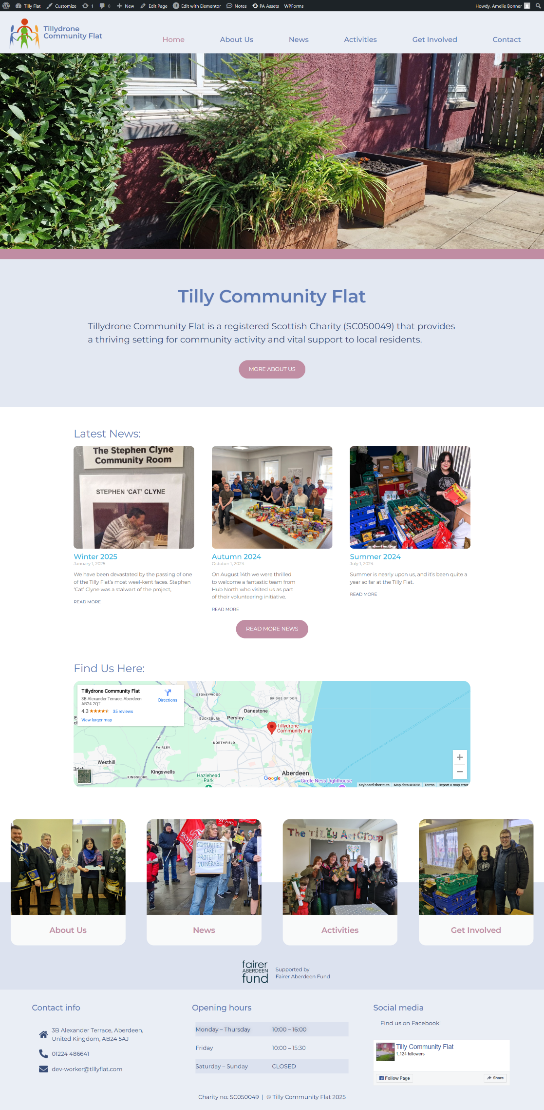
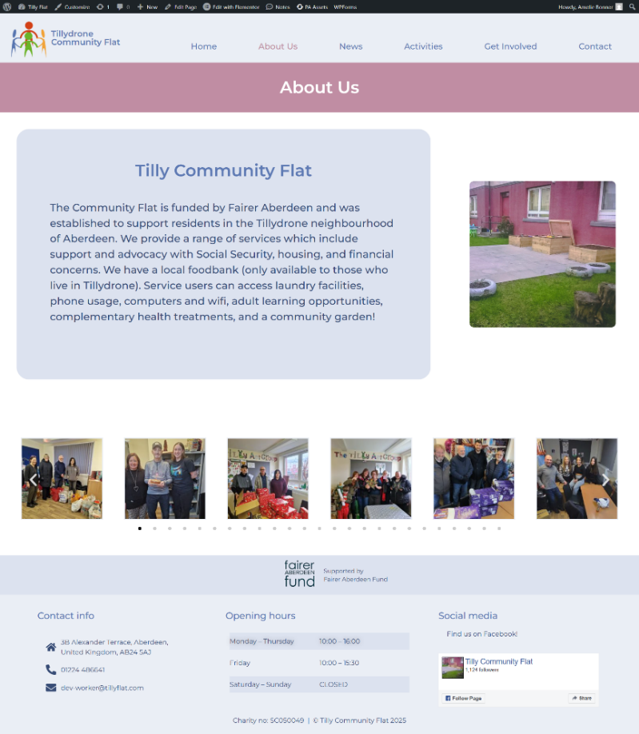

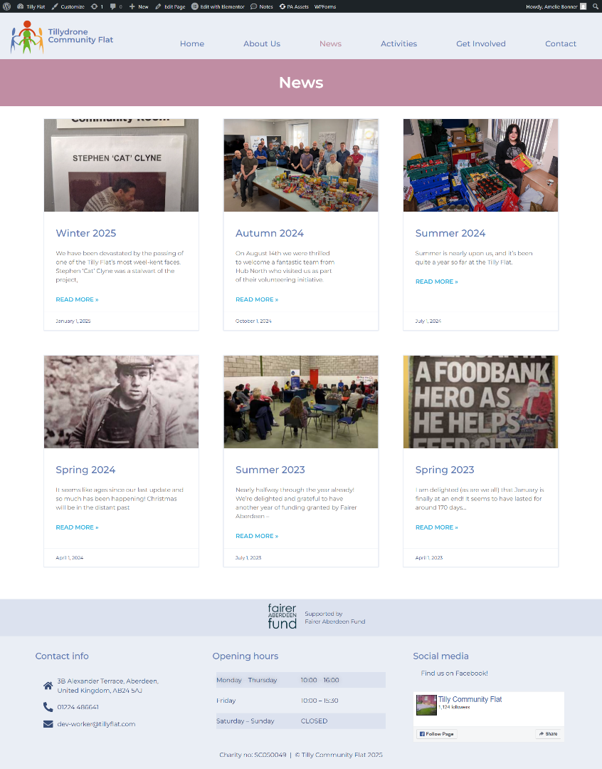

I found news posts from the Tilly Tattle magazine with updates from the last few years written by the community flat so I made them into posts on the website and linked them on the news page.
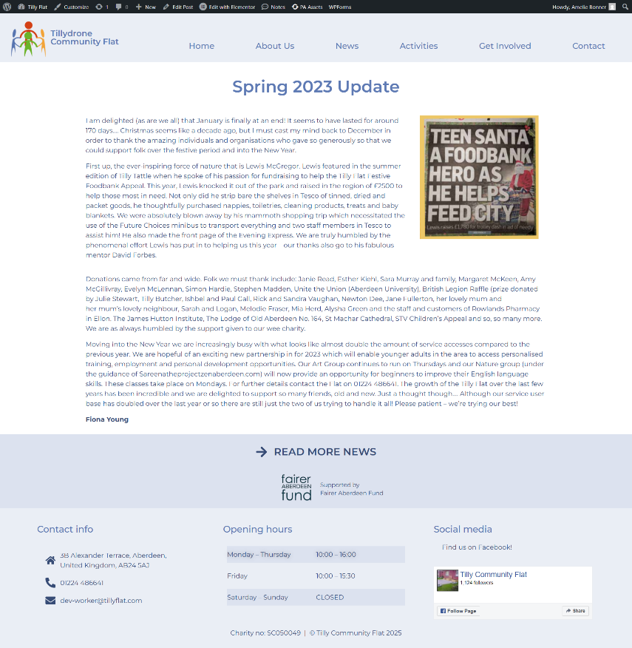

For the activities page, my client sent a list of activities that they run for the next few months, and I put them into a calendar and added it to the page. I also listed the activities for the week with the times below.
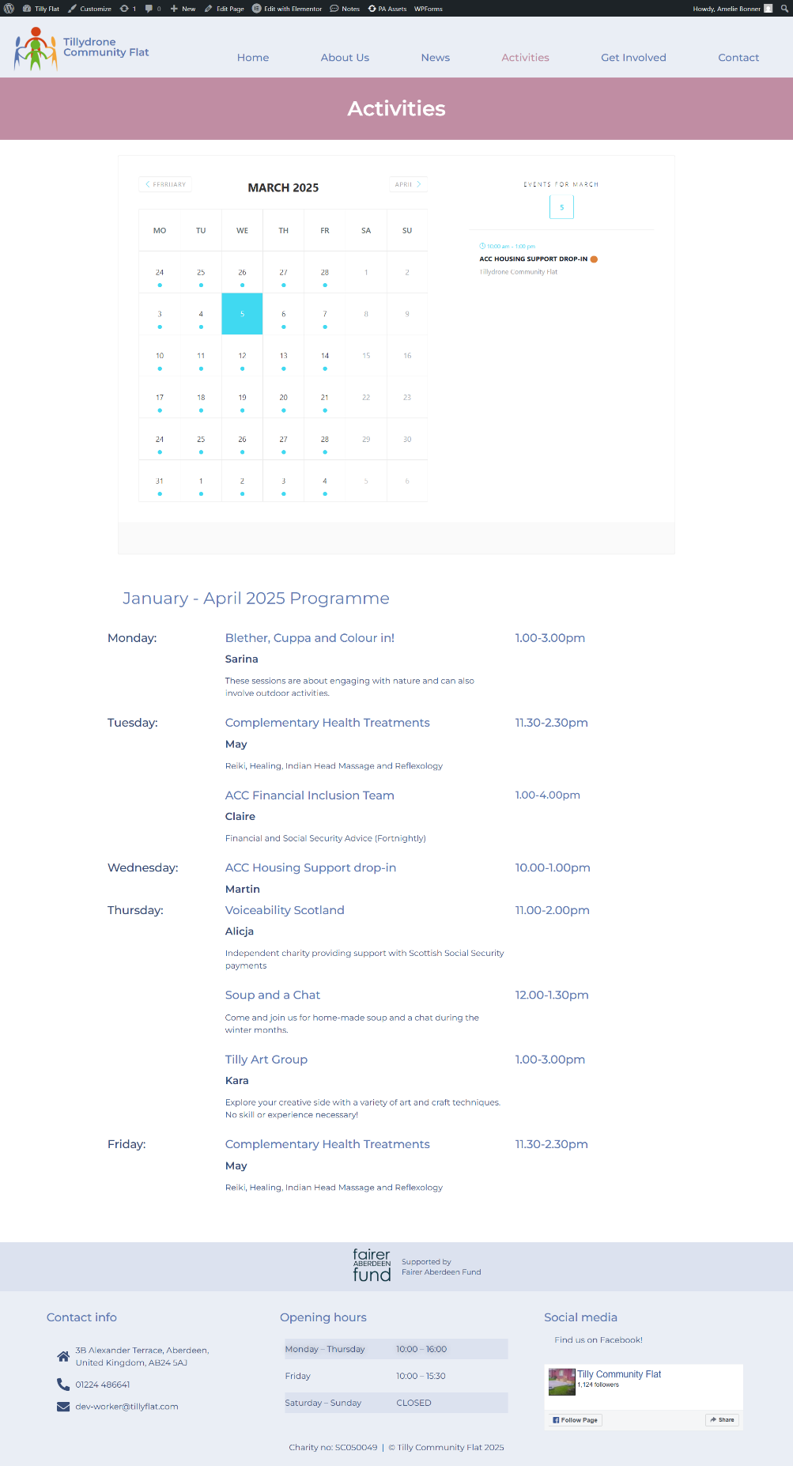

I created a form where users can input their name, email address, and phone number if they wish to get involved.
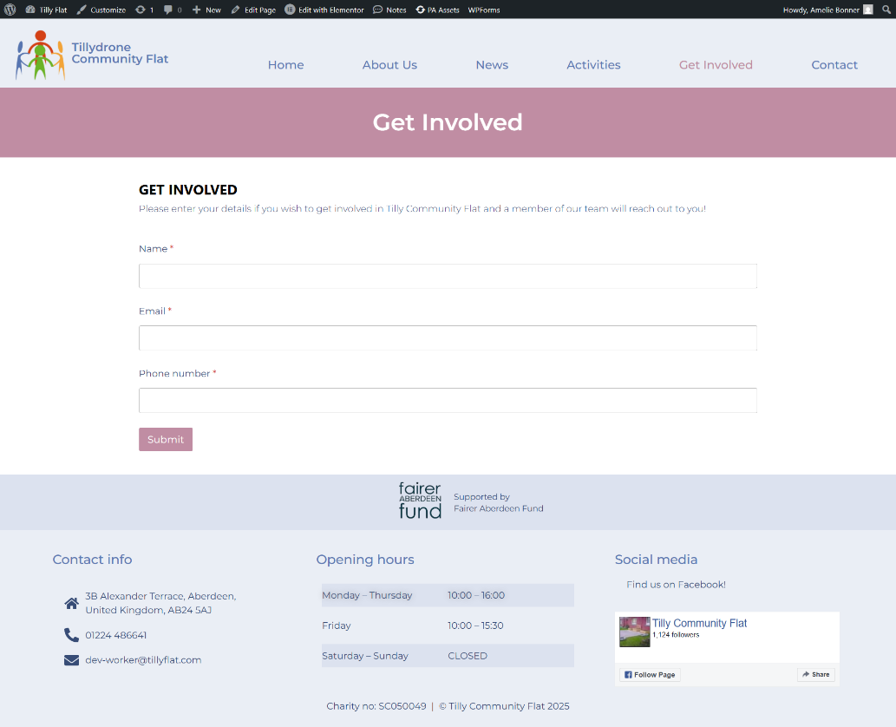

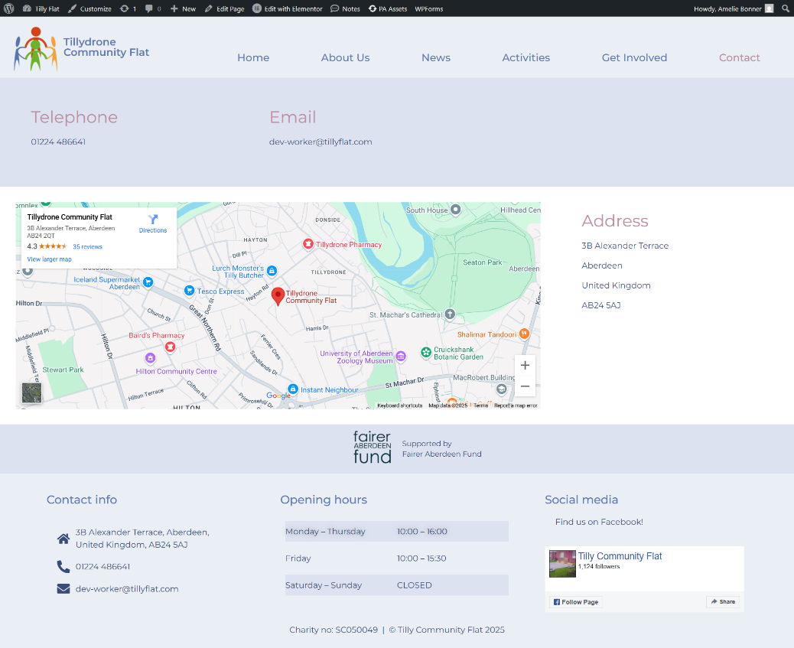

4.Target Date: | 26/03/2025 | Date Completed | 03/03/2025

FINAL PROJECT EVALUATION
5. Describe any problems you had and how you resolved them.
How satisfied are you with the quality of the final result? How well does it meet its purpose?
I found it difficult to find content for the website. I reworded text from other websites that spoke about Tilly Community Flat for the about us sections and took pictures from the Facebook page. I also took the posts from the Tilly Tattle and added them to the news page for extra content and information about what the flat does. The news posts were challenging because I had to create 6 extra pages with a consistent layout. I made templates of the header and the footer so if I changed anything, like the logo, it meant I wouldn’t have to edit it on every single page. I originally had every day in the opening hours in the footer, but it made the footer too tall, so I condensed it to Monday-Thursday, Friday, and Saturday-Sunday. Originally, I planned to have pages about the team and partners, but I struggled to find enough information on either so I added the main sponsor into the footer of all the pages because the client asked to have their partner mentioned. Overall, I am satisfied with the quality of the final result. I think that it is informative and easy to navigate. The client asked for it to have a clean and simple look and I think that I managed to achieve that. The website allows users to get in touch with the community flat team easily and it provides news and information on what they do, the activities that they provide, and it shows where to find them. I was able to communicate well with the client and adapt the website according to her feedback. I also used my creativity when designing the website. In the future, I could work on improving my focusing skills to complete the project quicker without as many changes.

6. feedback from requestor:

How satisfied are you with the quality of the final project result? How well does it meet its purpose?
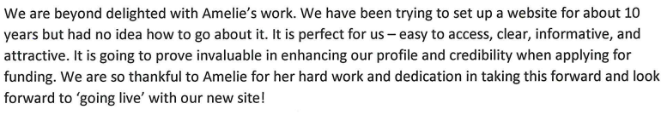

Apprentice Signature | REQUESTOR Signature
AMelie Bonner | 
Date 28/03/25 | Date

