Initial Planning
- HTML
Title: “Quiz Game”
Start button
3 question sections (1 at a time)
Final score display
Play Again button
- CSS
center everything
Nice button styles (round + black)
White background for questions
- JavaScript
startgame() then shows Q1
modalTwo() + modalThree() then go to next questions
showResults() then checks answers and shows score
restart() then it resets the game
Testing
- Try right/wrong answers
- Try upper/lowercase
- Make sure score and reset work

Pseudocode
First, write down the questions and the correct answers.
Start the game by hiding the start button and intro message, then show the first question.
When the user clicks “Next,” hide the current question and show the next one.
After the last question, get the user’s answers, turn them all to lowercase, and compare each one to the correct answers.
For every correct answer, add one point to the score.
Show the user their total score and display a “Play Again” button.
When the user clicks “Play Again,” reset the score to zero, clear all the answers they typed, hide the results, and show the intro and start button again.

Flow Diagram
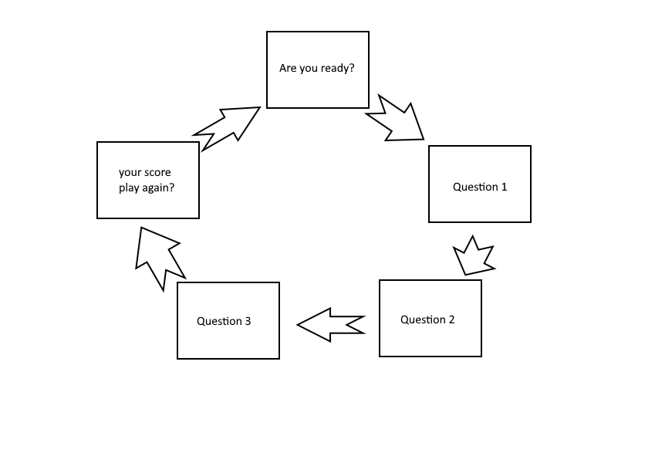

Wireframe
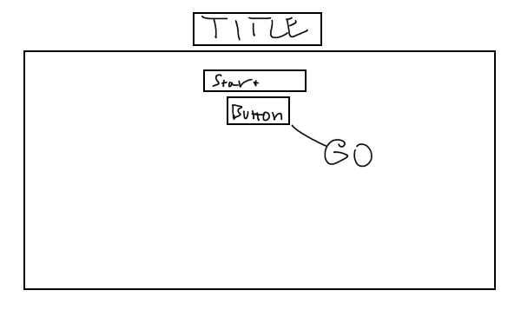
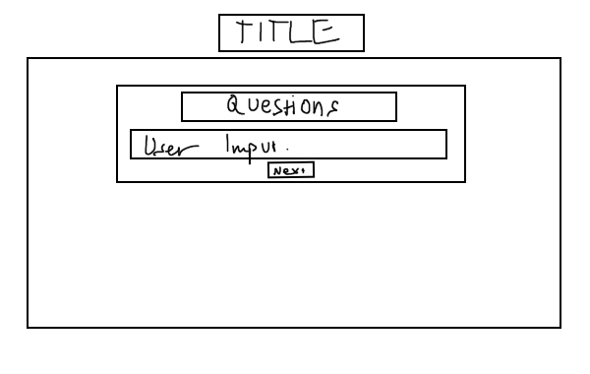
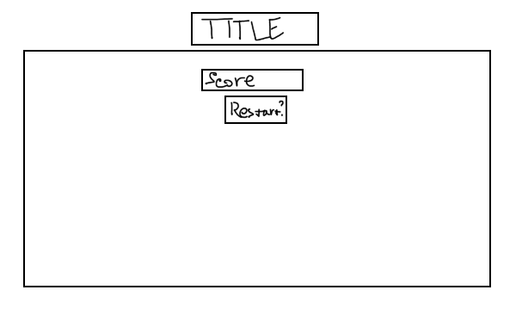
Test Log  What I Tested | Expected Result | Actual Result
Clicked "Begin" | First question appears | First question showed
Clicked “Next” on Q1 | Q2 shows, Q1 hides | Worked as expected
Clicked “Next” on Q2 | Q3 shows, Q2 hides | Worked as expected
Answered all correctly (8, Paris, Lebron James) | Score = 3/3 | Score showed as 3/3
Typed answers in lowercase | Score still correct | Worked correctly
Typed wrong answers | Lower score shown | Score was 0/3
Clicked "Play Again" | Game reset, start button shows | Game reset properly
Left answers blank | Score should be 0 | Score was 0/3
Typed with extra spaces (e.g. " Paris ") | Answer should still be counted | Answer was counted

Developer Notes
What the game is:
This is a basic quiz game made with HTML, CSS, and JavaScript. It asks 3 questions, one at a time. When you finish, it shows your score out of 3 and gives you an option to play again.

How it works:
- click the “Begin” button.
- The first question shows up.
- After each question, you click “Next” to go to the next one.
- After the third question, your answers are checked.
- You get a score at the end.
- You can click play again to restart the game.

What’s in the code:
- Html: Sets up the structure of the game (title, buttons, question boxes).
- css: Styles the page (colours, fonts, button looks).
- Java script: Makes the game work (showing questions, checking answers, scoring, restarting).

How the answers work:
- The user types their answer in a text box.
- Answers are turned into lowercase and trimmed to remove spaces.
- If the typed answer matches the correct one, you get a point.

