The client wants me to create an app which promotes healthy eating and living to my chosen age range of school children. I will aim to have the target audience of the app be primarily early primary school pupils, around the ages of 5-7. The app must contain at least six separate pages which must feature three different types of media. My plan for these pages is to have a homepage which allows easy access to the remaining five, and then 4 information pages about different topics related to healthy living. And my final page will be a quiz on all the information present on the app. For the types of media required I will use text, images and videos. Text as it is the easiest way to convey information, and images and videos to help it appeal more to the younger target audience, it should also consist of a bright colour scheme I will need to create wireframes for each page to assist with the actual building of the app, this will be done using lucidcharts. The first information page will contain information about healthy eating, such as which foods to limit and which you should eat more of. The second page will have information regarding exercise and other ways of staying active, the third will contain information about sleep, such as how much you should be getting each night to remain healthy. And the fourth will contain information to do with hygiene, such as hand washing and brushing your teeth. I will start the developing process by creating the homepage with use of HTML and CSS, as I will be able to carry over and reuse the basic structure of this for the rest of my pages, with slight tweaks for each one, I will finish with the development of the quiz page. Which will make use of Javascript
The main tool I will use for developing the app is visual studio code, this provides syntax highlighting,debugging tools and live preview capabilities for HTML, CSS, and Javascript.
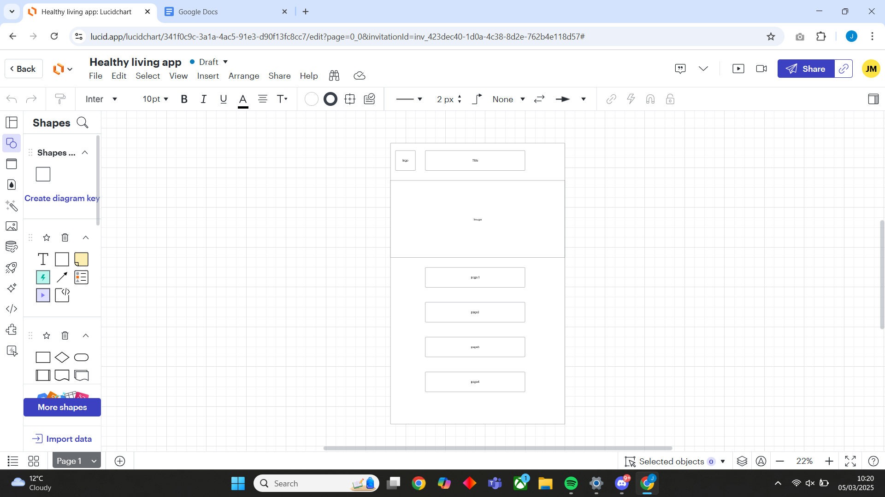
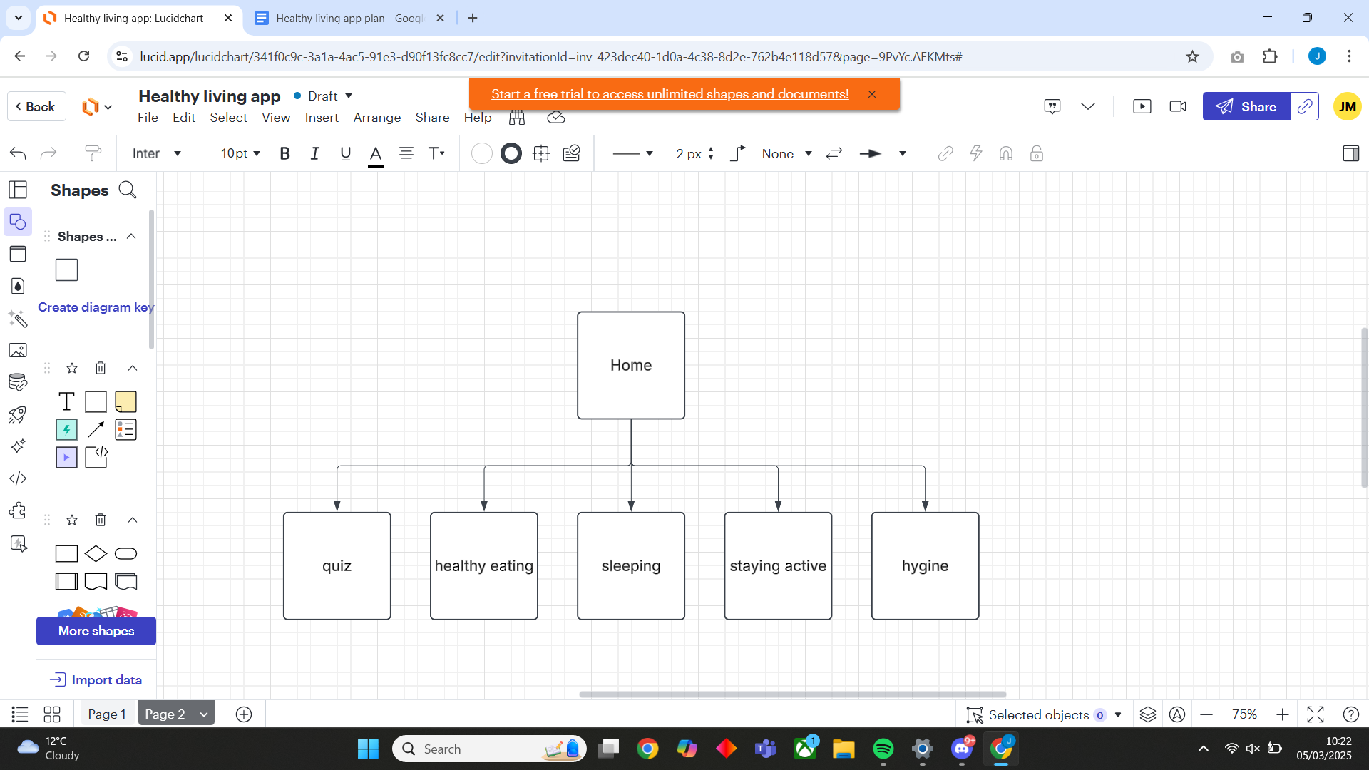
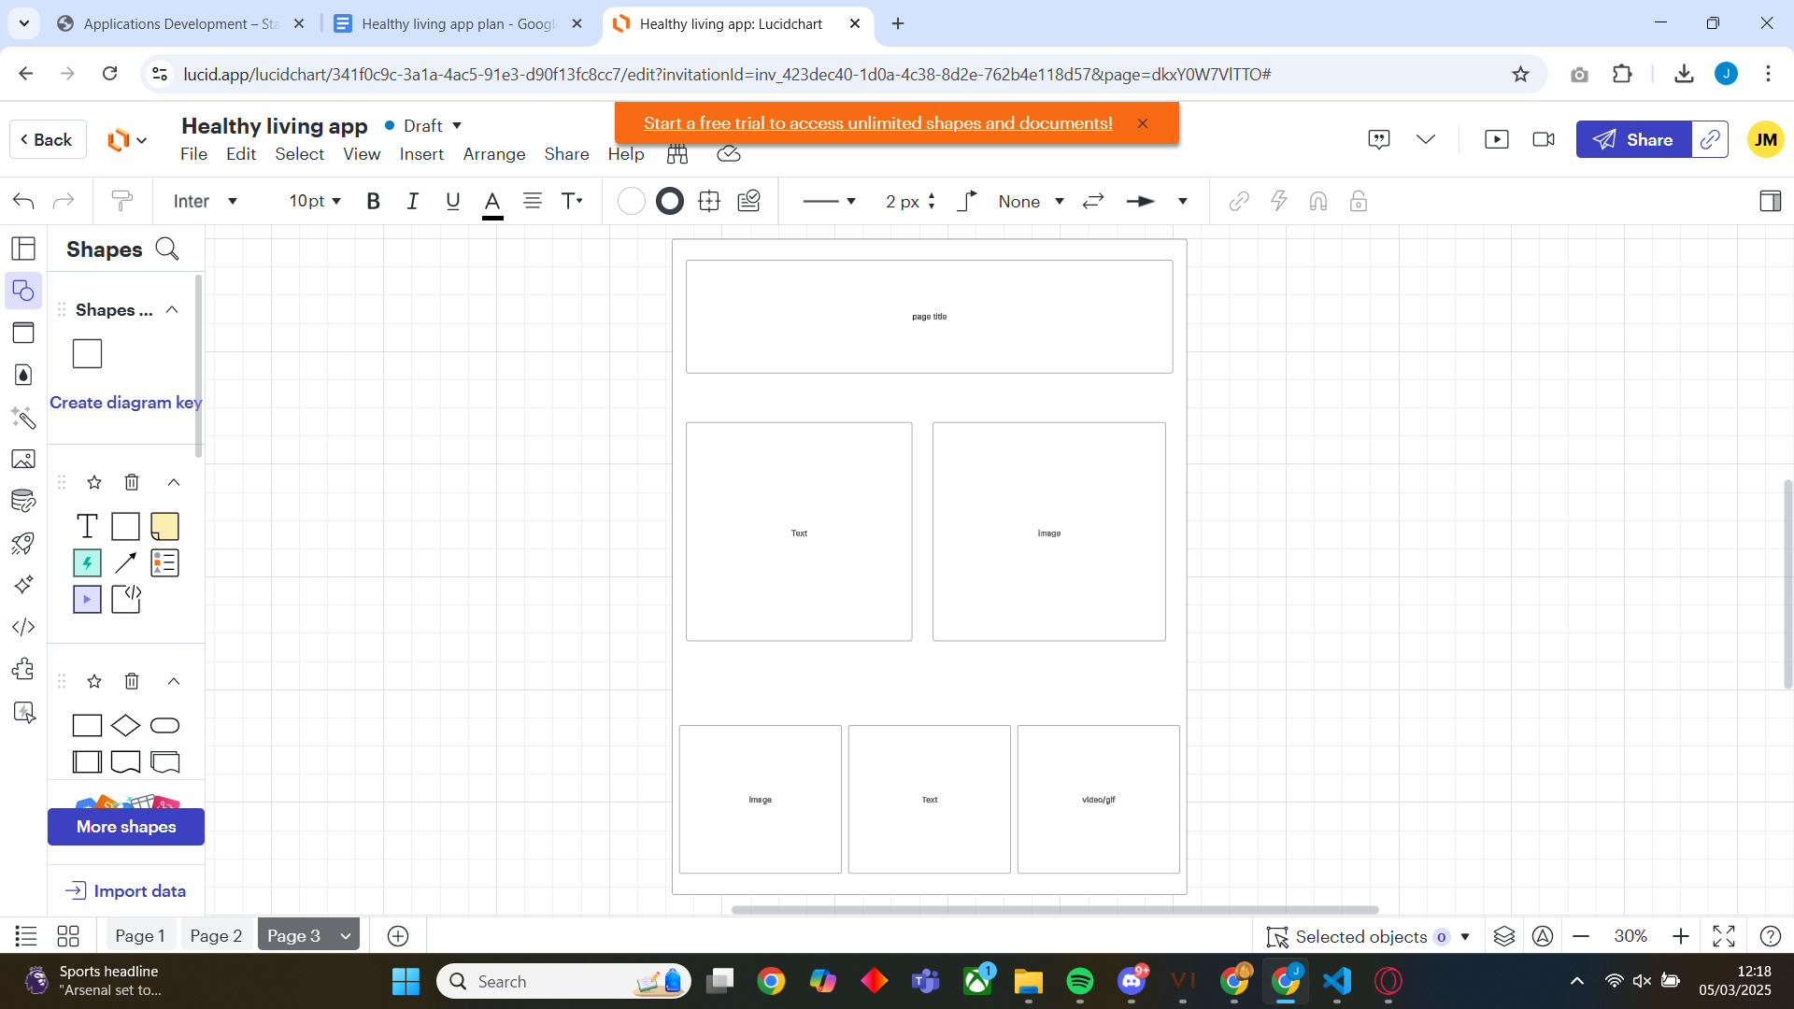

Week 1 | Week 2 | Week 3
homepage | Sleeping page | Hygiene page
Healthy eating page | Staying active page | quiz

Test Plans

Area tested | Pass / fail | error | Changes made
Menu drops down when button pressed | pass
Images load on all pages | pass
Switching between pages works | pass
Quiz questions change when next button pressed | pass
Score is correctly shown at end of quiz | pass
Score and answer boxes reset when quiz is reset | pass
Video loads and plays | fail | Video does not load | Replace link in code with link found from <share - embed>
Dropdown menu closes when button pressed | pass

Resources

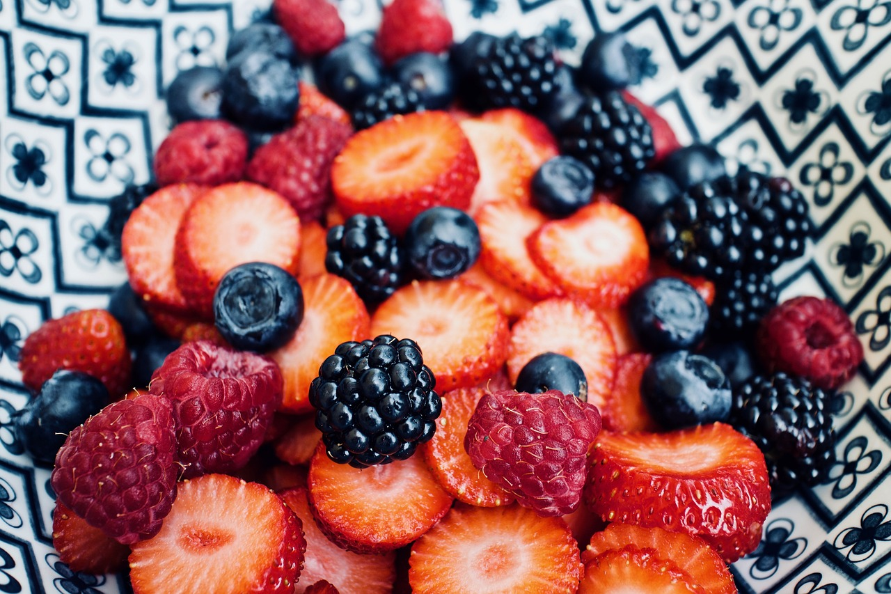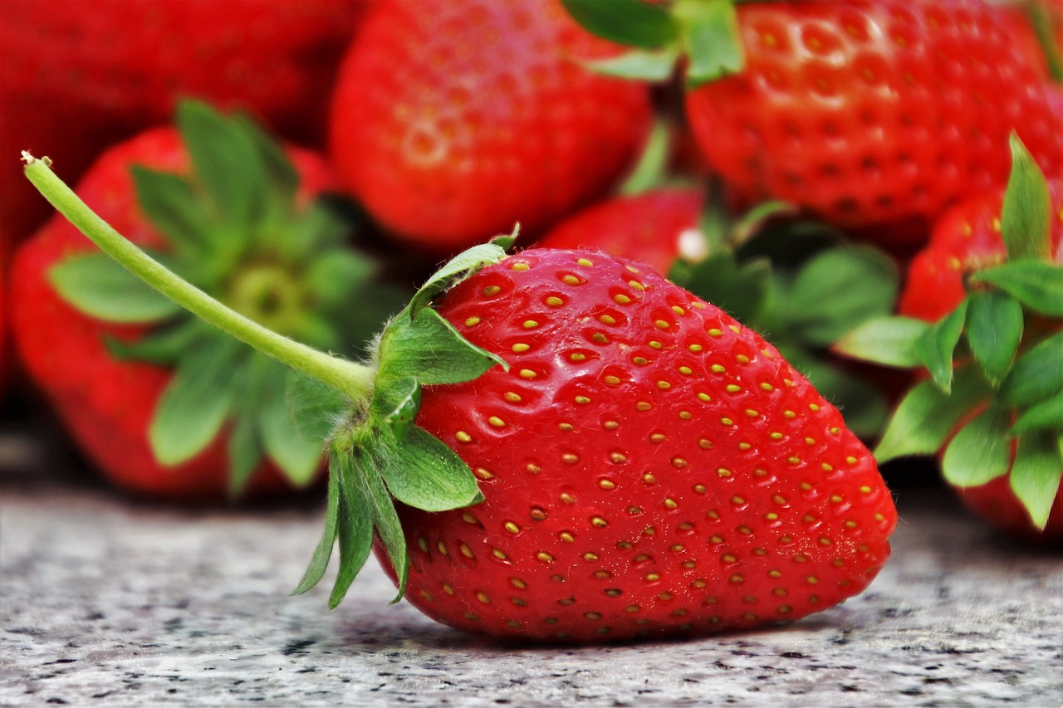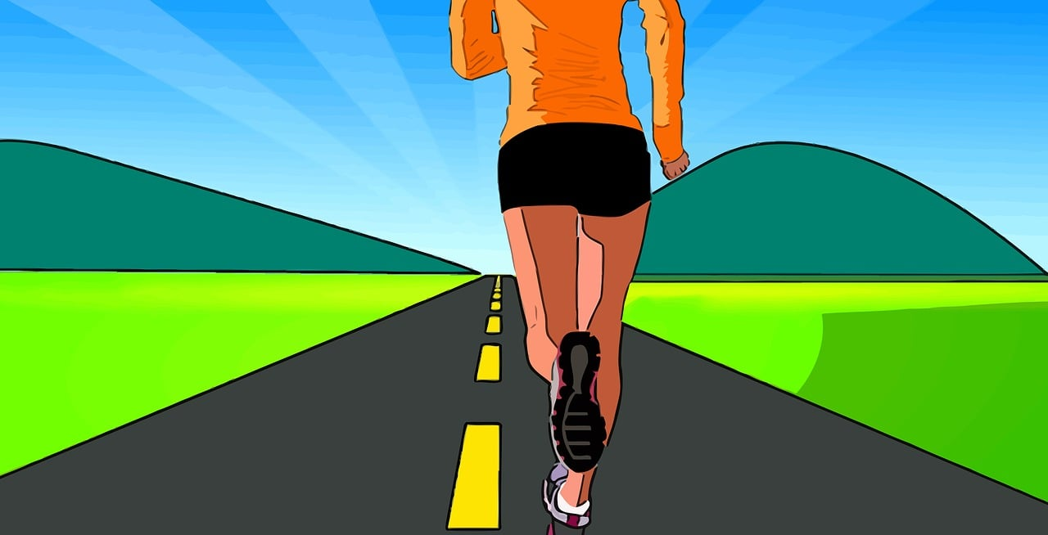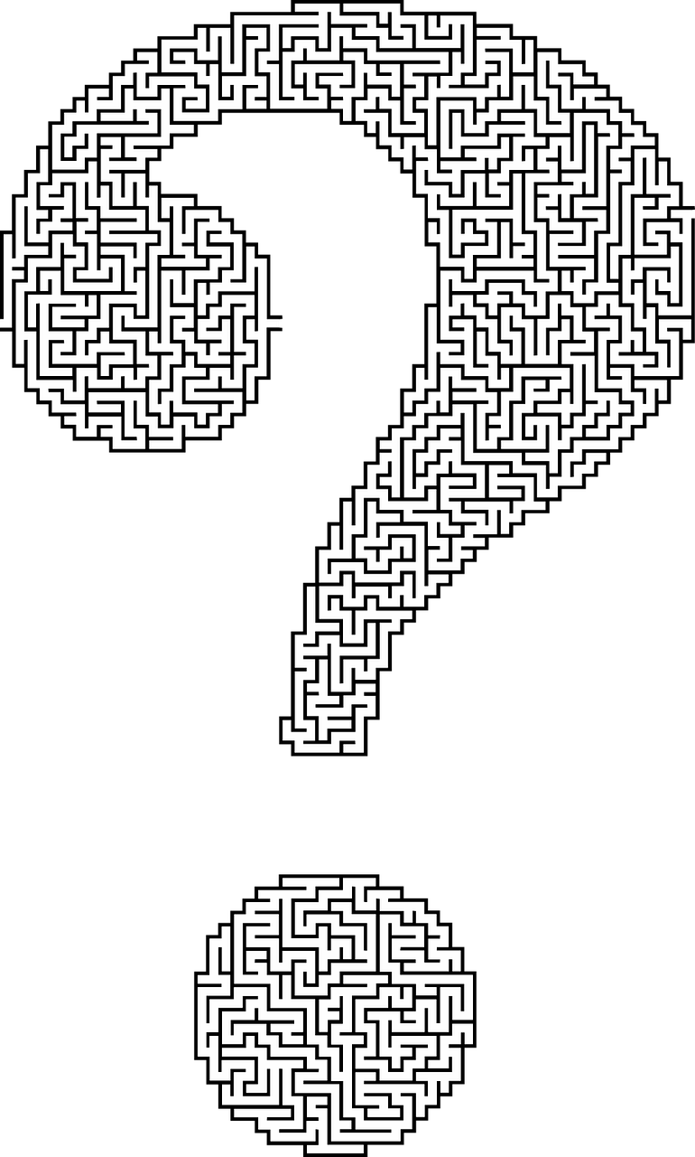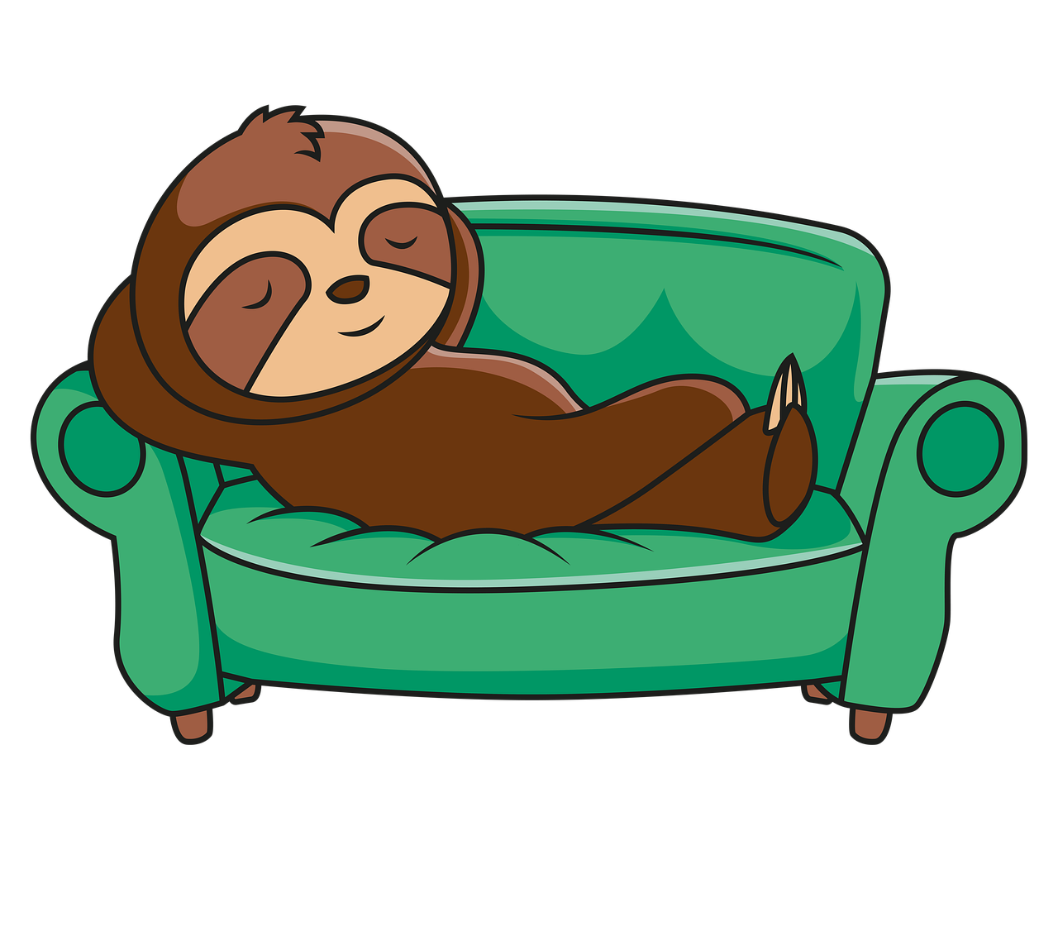https://www.youtube.com/watch?v=7pwV0sPNYCs

Evaluation

Overall the app meets all requirements of the brief and conveys the information in a way that would hopefully be engaging for children around the age of 5 - 7. Some possible improvements that could be made would be making the app look cleaner and more appealing, possible through using different shapes and borders around images and text. Or by making it more interactive, such as having images change using rollovers The quiz portion of the app could be improved by changing the order the questions appear in each time, or even by adding more questions.

